Volunteer Toolkit
How to Share the Gospel with Kids
There are so many methods that have been developed for clearly presenting the Gospel to children and youth. Take some time to find one that connects with you and feels comfortable for you to share naturally (without relying on your notes!).

When helping children to apply a truth within their lives and contexts, you can help them to take an abstract idea and concretize it by personalising the truth for yourself. By demonstrating how what you are teaching is true in your own life you build credibility with the students, and help them in their understanding and application.

As you talk to kids about salvation, share about how Jesus has made a difference in your life. Remember to keep your language simple. Big words, symbols and metaphors can be confusing for children. Ask open-ended questions that prompt them to answer more than yes/no. For example: What do you like about Jesus? Why do you think He had to die? How have you seen God at work in your life lately? When sharing your testimony, remember to hit 3 key ideas:
- Who were you before you knew Jesus? (what did you struggle with, what was your attitude like...) This is a tough one for "church kids" to understand as many of them feel as though they have always known Jesus. Help them to differentiate between knowing about Jesus and choosing to know Jesus.
- How and why did you choose to follow Jesus with your whole heart and life? (how did you learn about Jesus, what and who helped you to make that decision, what did you do...)
- What is the difference Jesus makes in your life? (how have you changed, what does knowing Jesus mean, what does your relationship with him look like in your day to day life...)

If children indicate that they are interested in personalising what they are learning, be sure to include the child's parents. It is their role to be the key spiritual influence in their child's life, so it should be their privilege to pray with their child (if possible this is ideal, but not always the reality with families that may not have believing parents).

How to Pray with/for Kids
Leading Children in Prayer
There are SO many techniques and strategies for leading children in prayer. However, one of the most important things that we can teach children about prayer is that it is a conversation between us and God that involves both speaking and listening. Children can hear God’s voice! And God knows, hears, and responds to the prayers that they pray to him. Take time to explore both listening and speaking in prayer with the children you serve.

Simple Prayer of Salvation with Children
Dear Jesus,
I'm sorry that I make poor choices. I know it is not what you have created me to do, and keeps me from being Your friend. I'm sorry for my sin. Please forgive me.
Thank You for dying on the cross for me.
I believe that You are alive, and that You love me.
Thank You for forgiving me. I want to be Your friend, and I want to trust You with my life, so that I can know You better, and change to be more like You. I love You.
Amen

Praying for Children (based on Luke 2:52)
Pray for Wisdom:
- Pray for the choices and actions of your small group while they are at HOME, SCHOOL and ACTIVITIES.
Pray for Them Individually
- Pray specifically for each child’s prayer requests, and for new children that join your small group. As they come to your mind throughout the week, use that as a cue to pray for that child.
- Pray that they would grow in their self understanding and identity as a child of God.
Pray for Faith
- Pray that they are taking time to learn how to trust God more by reading their Bibles, talking and listening to God, and growing in their faith.
Pray for Relationships
- Pray for their relationships with their family, friends and peers. Pray that they can be a light, and that they would try to become more like Jesus in these key areas.

How to Read the Bible with Kids
Preschool (Pre-readers)
Use a beginners Bible to find the story from that week’s lesson. You can put a sticky note in the approximate location for the verse in the beginners Bible if you are learning a verse together. Try singing or creating motions to reinforce the verse that you are teaching.

Kindergarten & Grade 1 Students (Early readers)
Guide children to open the Bibles to the marked page. Point to the title of the book and say it aloud. Then guide children to find the big number for the chapter number. Finally, guide them to look under the big number for the little verse number. Tell them to leave their finger on the verse as you read the verse aloud. Then lead everyone to say the verse together.

Grade 2/3 Students (Primary readers)
Guide them to open their Bibles to the front and find the table of contents. Lead them to find the book either in the list for the OT or NT. Help the kids find the page for the book. When they find the book, explain that the big numbers on the page are the chapter numbers. Explain that the small numbers are verse numbers.

With Grade 4/5 Students (Intermediate readers)
Ask kids to tell you whether the book is in the OT or NT. Using that clue they can try to find the book without using the table of contents. Explain that the big numbers on the page are the chapter numbers. Explain that the small numbers are verse numbers.
Always be sensitive to individual reading skills, and the potential that a child may be uncomfortable reading in front of a group due to a learning difficulty. Only have willing students read aloud, but encourage all children to develop the skills necessary to locate verse references on their own.

Spiritual Disciplines/Practices and Doctrine for Kids
Describe key practices for helping kids grow in their faith (Bible reading, prayer, contemplative practices, worship, etc.) and children’s participation in corporate practices of: Communion, Baptism, Child Dedication, Prayer, Scripture, the Church, Tithing, etc.

How to Journey with Kids in their Faith Formation
Basic Child Development Characteristics
 | Intellectual | Physical | Emotional | Social | Spiritual
4-5 years | - Simple counting  - Learning the alphabet  - Literal (concrete) thinkers  - High level of fantasy | - Gross motor skills more developed than fine motor skills  - Learns through the senses  - Rapid growth  - Constant movement | - Learning to share and  take turns  - Imitation  - Largely focused on self needs | - Curious and questioning  - Short attention span (2-3 minutes)  - Seeks affirmation  - Some concern for others well-being | - Basic familiarity with God and the Bible  - Enjoys prayer  - Able to be sorry for doing wrong  - Knows God loves them and is their friend
Grade 1 | - Eager to learn  - Focuses on the present  - Literal  (concrete) thinkers  - Enjoys make-believe play | - Learning coordination of fine motor skills  - Varying beginner levels of reading and printing skills | - Being first is important  - Being the helper is important  - Play choices depend on individual preference  - Desires to be accepted and make friends | - Growing in independence  - Emotionally sensitive  - 5-10 minute attention span | - Can apply biblical concepts to their lives  - Enjoys prayer  - Eager to share their knowledge or thoughts about God  - Knows God can help them
Grade 2/3 | - Creative  - Can see other’s point of view  - Are aware of what is happening around them | - Developing good fine motor skills  - Loves to explore  - Have endurance | - Desires more status in peer group  - Cares about friend’s opinions  - May be shy in new situations | - Increased communication skills  - Teasing and criticism are common | - Aware of their need for God  - Many have knowledge of biblical facts and the overarching story of God
Grade 4/5 | - Articulate  - Developing ability to make ethical decisions  - Beginning to reason abstractly  - Concepts of time and space are clear | - Beginning to enter adolescence  - Have mastered most basic physical skills  - Competitive | - Likes to be with friends and peers who share similar interests  - Activities and interests influenced by peers/friends  - Respects authority, but will test limits | - Peer pressure becomes common  - Searching for identity beyond family unit  - Emotions can be unsteady as they develop | - Takes more ownership of their faith  - Enjoys missions projects and service projects  - Can share Jesus with friends  - Enjoys serving others

VARK Learning Styles
Children learn in many different ways, and have dominant learning styles that are the method through which they absorb, understand, express, and remember their learning. The 4 styles of learning are visual (seeing), auditory (listening), read/write (comb of visual and kinaesthetic), and kinaesthetic (active/sensory, involving the whole body). Our activities and lessons strive to engage all four learning styles.

Spiritual Types
Children also experience and encounter God in many different ways. The types of spiritual expression and connection can be represented by the Spirituality Wheel (you may have seen this with other words for the four sections. This one is simplified for use with children and youth). Where do you find yourself on this wheel when you feel most connected to God? What about the individual children that you are journeying with?
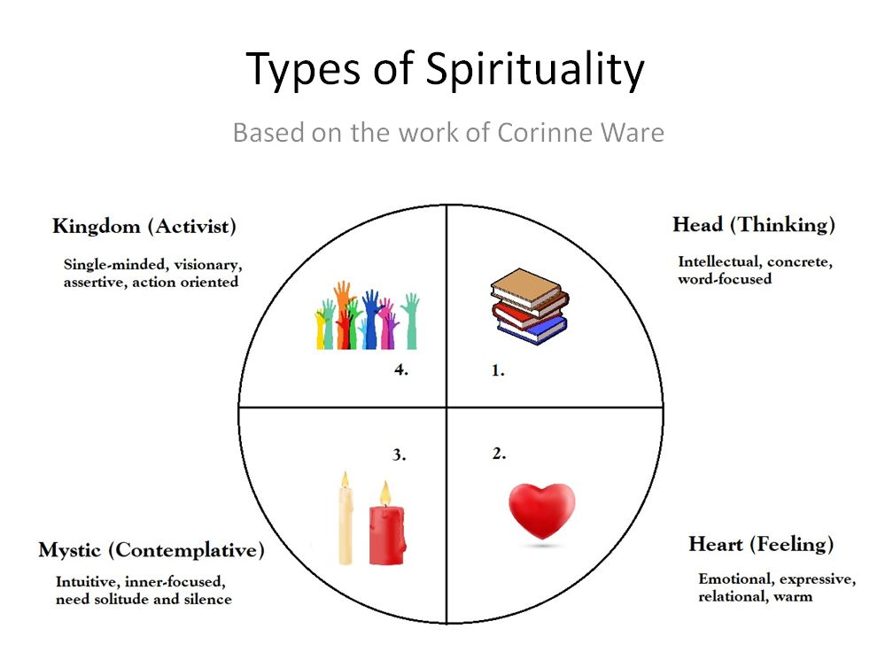

Some great tools for evangelism are: “The Wordless Bible,” “The Gospel in Three Circles” https://www.youtube.com/watch?v=5W8ynRMr59k, and a simple presentation based on John 3:16 “God Loves, God Gave, We Receive, We Believe.”
The WCD (Alberta) created a great resource on child development characteristics in 2016.
Spiritual Types Wheel was accessed March 2024: https://sjmc.on.ca/the-things-that-nourish-spiritual-practices/

